# Lab 4 PKI Lab

Name: Guo Yuchen

Student ID: 1004885

## Task 1: Becoming a Certificate Authority (CA)

Generate self-signed certificate for ModelCA:

$ openssl req -x509 -newkey rsa:4096 -sha256 -days 3650 -keyout ca.key -out ca.crt

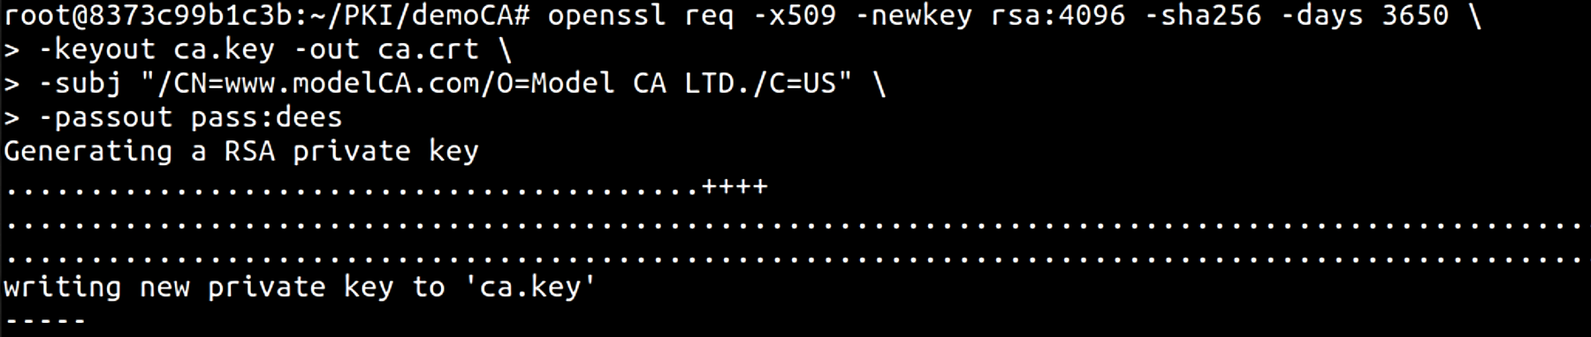

To see the decoded content:

$ openssl x509 -in ca.crt -text -noout

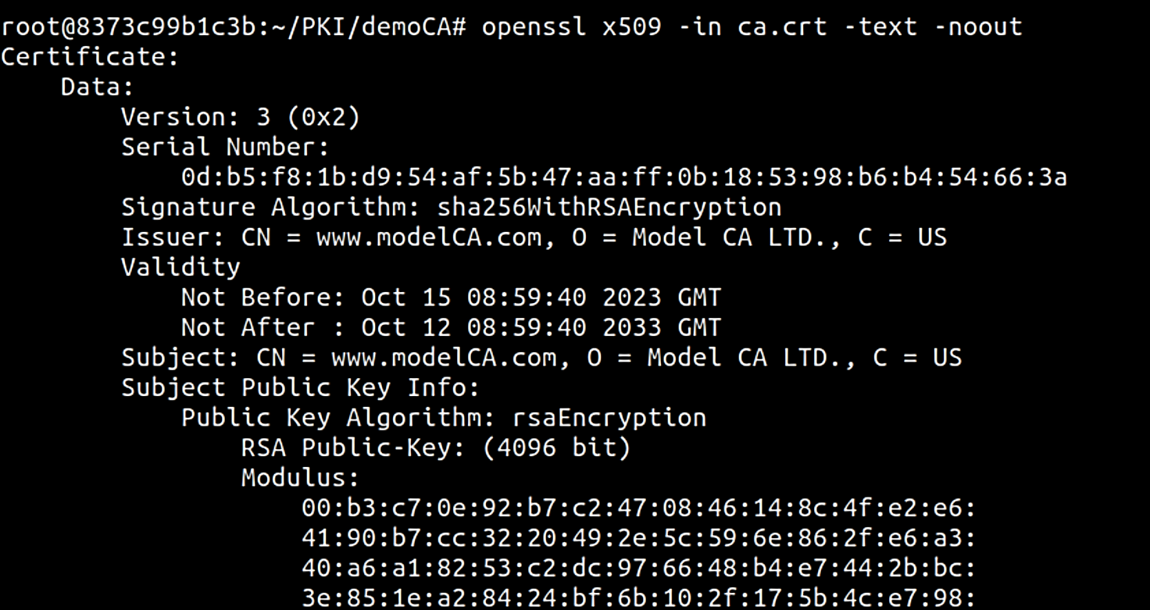

Certificate:

Data:

Version: 3 (0x2)

Serial Number:

0d:b5:f8:1b:d9:54:af:5b:47:aa:ff:0b:18:53:98:b6:b4:54:66:3a

Signature Algorithm: sha256WithRSAEncryption

Issuer: CN = www.modelCA.com, O = Model CA LTD., C = US

Validity

Not Before: Oct 15 08:59:40 2023 GMT

Not After : Oct 12 08:59:40 2033 GMT

Subject: CN = www.modelCA.com, O = Model CA LTD., C = US

Subject Public Key Info:

Public Key Algorithm: rsaEncryption

RSA Public-Key: (4096 bit)

Modulus:

00:b3:c7:0e:92…

Exponent: 65537 (0x10001)

X509v3 extensions:

X509v3 Subject Key Identifier:

E0:A5:4A:9E:10:1C:97:09:A2:D4:F1:83:B0:89:C1:ED:AE:4B:FE:25

X509v3 Authority Key Identifier:

keyid:E0:A5:4A:9E:10:1C:97:09:A2:D4:F1:83:B0:89:C1:ED:AE:4B:FE:25

X509v3 Basic Constraints: critical

CA:TRUE

Signature Algorithm: sha256WithRSAEncryption

68:7c:8e:79… [See Appendix.1 for full content]

$ openssl rsa -in ca.key -text -noout

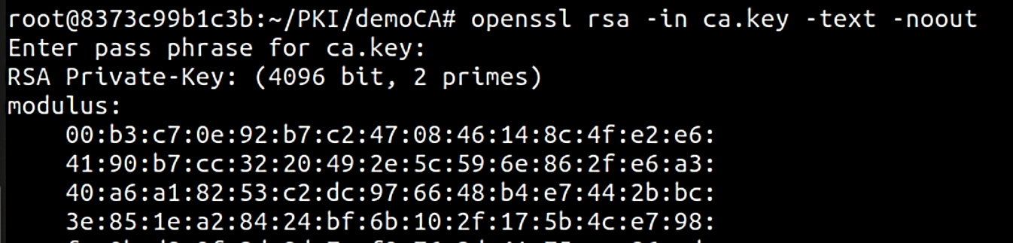

[The full content is recorded in Appendix.2 ]

• *What part of the certificate indicates this is a CA’s certificate?*

**CA:TRUE**

• *What part of the certificate indicates this is a self-signed certificate?*

**Subject is the same as issuer:**

* **Subject: CN = www.modelCA.com, O = Model CA LTD., C = US**
* **Issuer: CN = www.modelCA.com, O = Model CA LTD., C = US**

*• In the RSA algorithm, we have a public exponent e, a private exponent d, a modulus n, and two secret numbers p and q, such that n = pq. Please identify the values for these elements in your certificate and key files.*

* **public exponent *e***: 65537
* **modulus *n*:**



* **private exponent *d*:**



* **prime 1 p:**



* **prime 2 q:**



By the way, to convert the hex strings copied from terminal to integer, I wrote a python function:

*def* hex_to_int(*hex_string*):

    splited_hex = *hex_string*.replace("\n","").replace(" ","").split(":")

    res = ""

    for s in splited_hex:

        res += s

    return int(res, 16)

## Task 2: Generating a Certificate Request for Your Web Server

Generate a CSR with 2 alias:

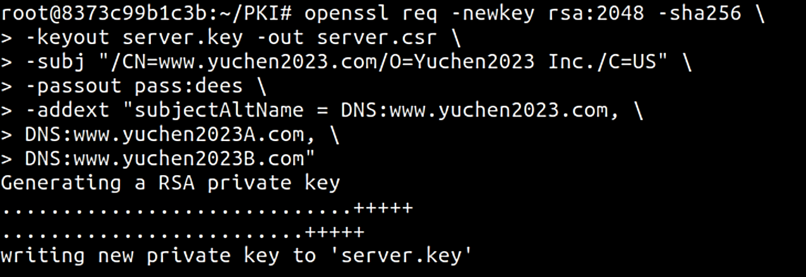

$ openssl req -in server.csr -text -noout

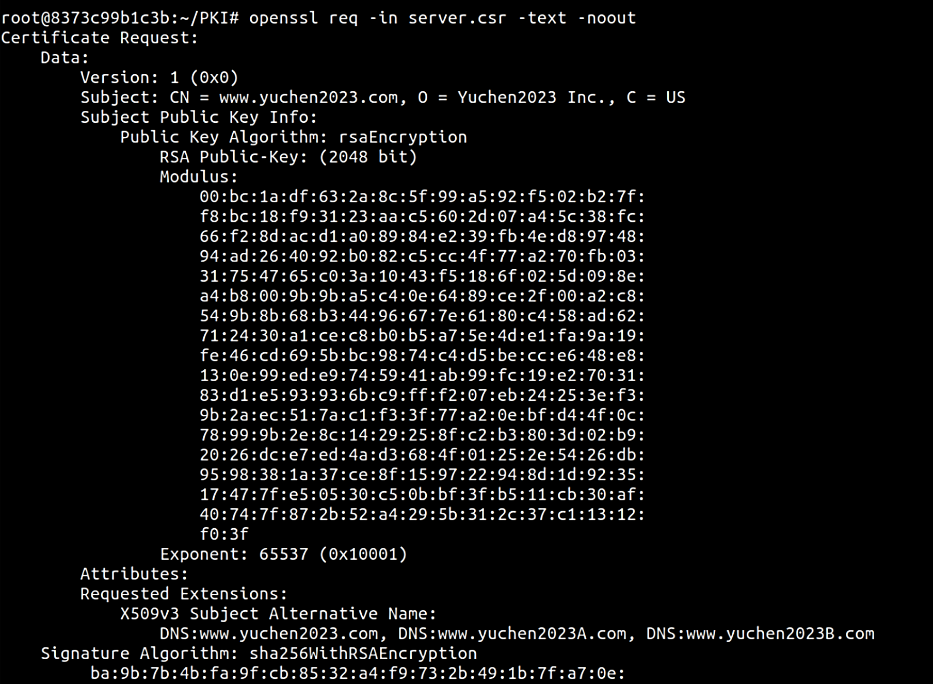

[The full content is recorded in Appendix.3 ]

$ openssl rsa -in server.key -text -noout

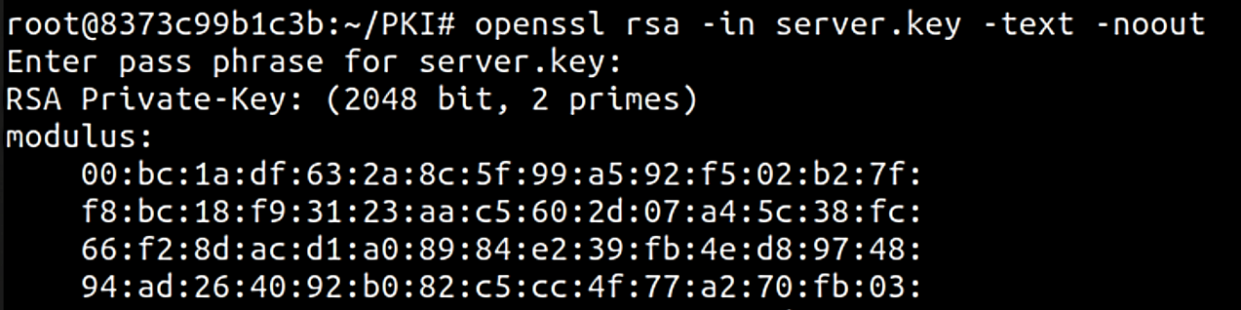

[The full content is recorded in Appendix.4 ]

## Task 3: Generating a Certificate for your server

Turn the certificate signing request (server.csr) into an X509 certificate (server.crt), using the CA’s ca.crt and ca.key:

openssl ca -config /etc/ssl/openssl.cnf -policy policy_anything \   
-md sha256 -days 3650 \   
-in server.csr -out server.crt -batch \   
-cert ca.crt -keyfile ca.key

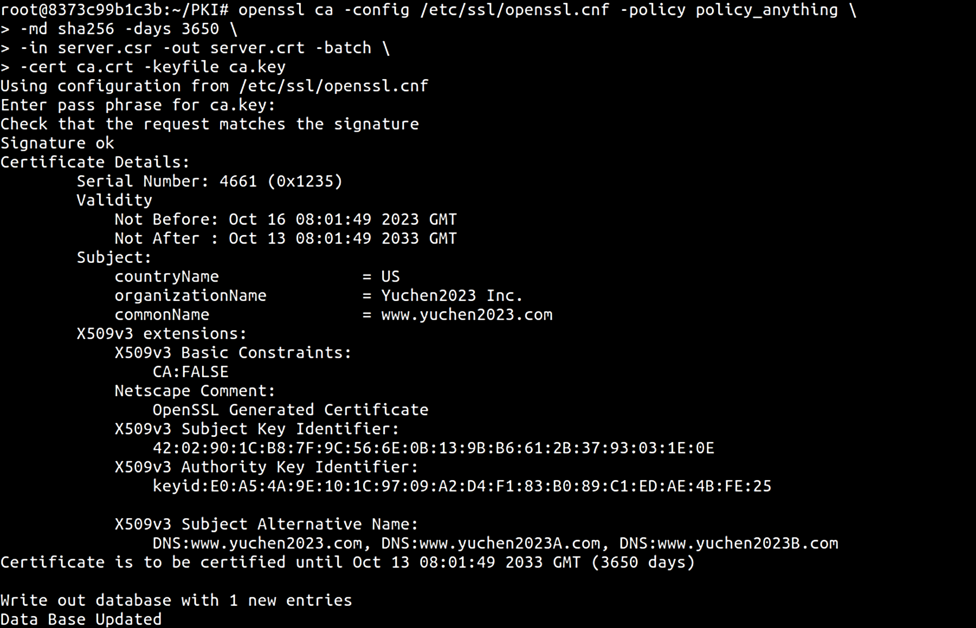

$ openssl x509 -in server.crt -text -noout

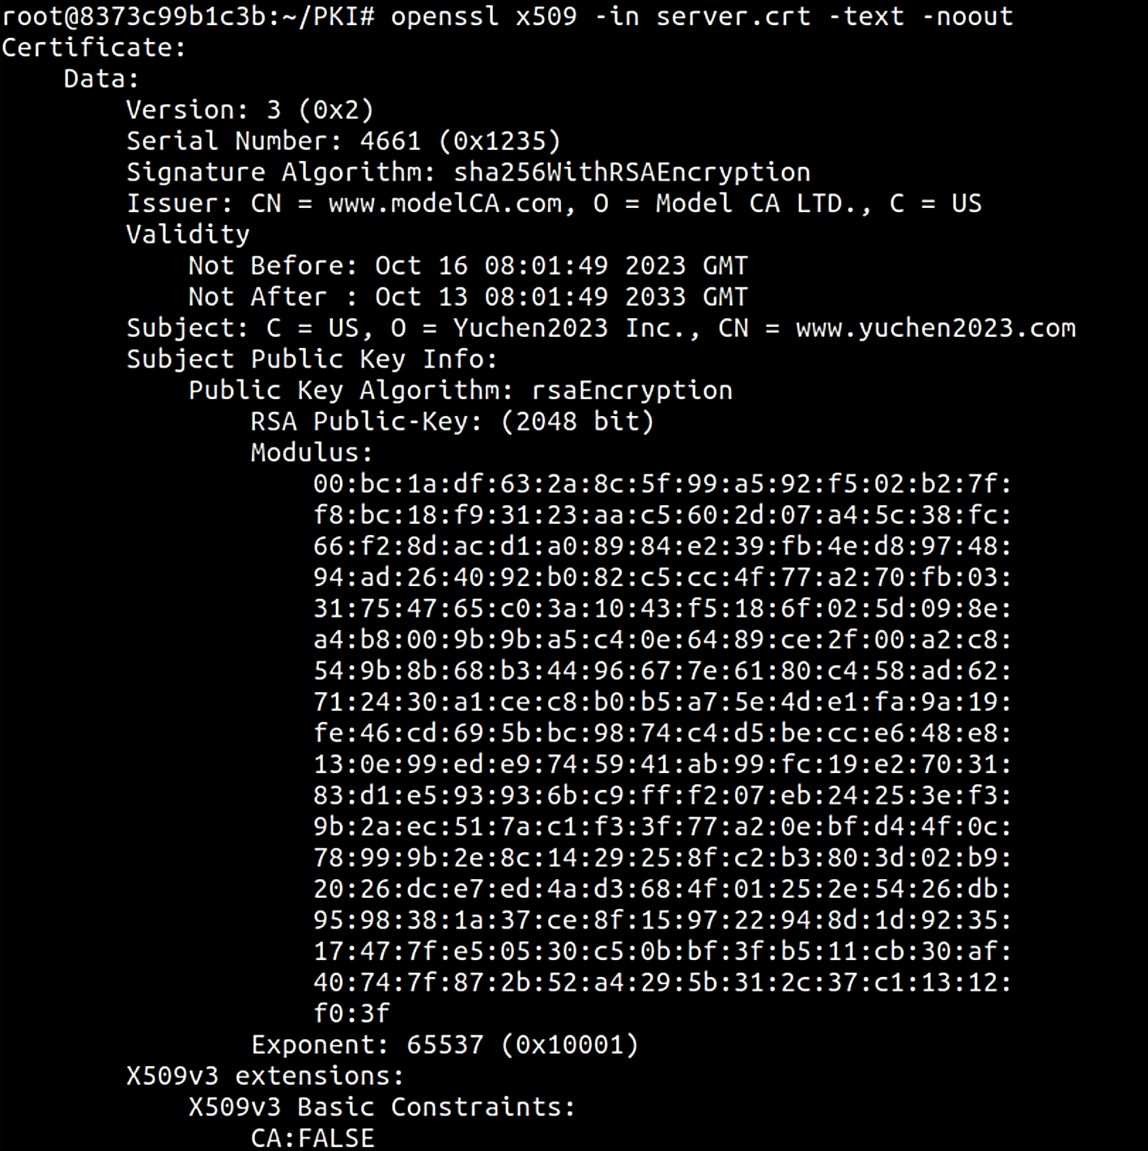

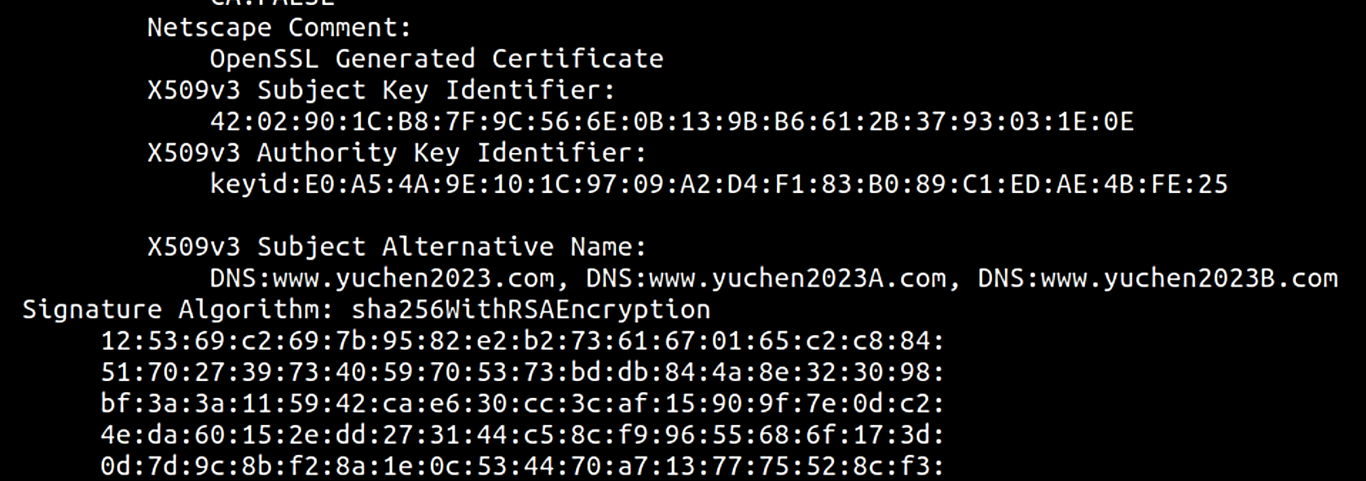

[The full content is recorded in Appendix.5 ]

In X509v3 Subject Alternative Name, we see that 3 names are recorded:

* DNS:www.yuchen2023.com,
* DNS:www.yuchen2023A.com,
* DNS:www.yuchen2023B.com

Thus, alternative names are included.

## Task 4: Deploying Certificate in an Apache-Based HTTPS Website

Create yuchen2023_apache_ssl.conf inside /etc/apache2/sites-available:

<VirtualHost *:443>  
 DocumentRoot /var/www/yuchen2023  
 ServerName www.yuchen2023.com  
 ServerAlias www.yuchen2023A.com  
 ServerAlias www.yuchen2023B.com  
 DirectoryIndex index.html  
 SSLEngine On  
 SSLCertificateFile /certs/yuchen2023.crt  
 SSLCertificateKeyFile /certs/yuchen2023.key  
</VirtualHost>  
  
<VirtualHost *:80>  
 DocumentRoot /var/www/yuchen2023  
 ServerName www.yuchen2023.com  
 ServerAlias www.yuchen2023A.com  
 ServerAlias www.yuchen2023B.com  
 DirectoryIndex index_http.html  
</VirtualHost>

Copy generated server certificates to /certs and rename according to the config file defined above:

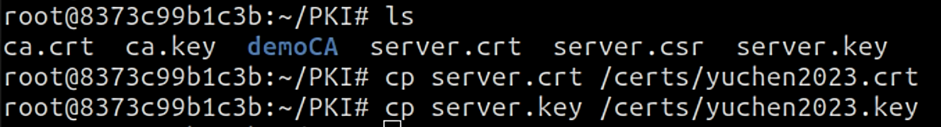

Enable the site by :

$ a2ensite yuchen2023_apache_ssl.conf

$ service apache2 restart

After setting up the apache server, browse the web, and it shows the expected content for port 80 request:

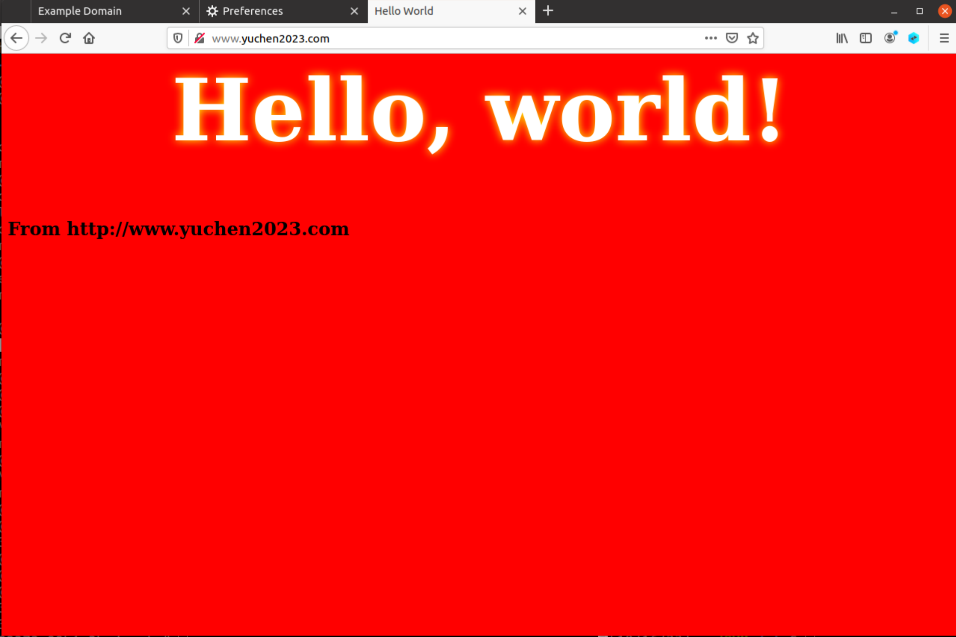

However, when visiting https site, it shows a warning with the error code: SEC_ERRO_UNKNOWN_ISSUER.

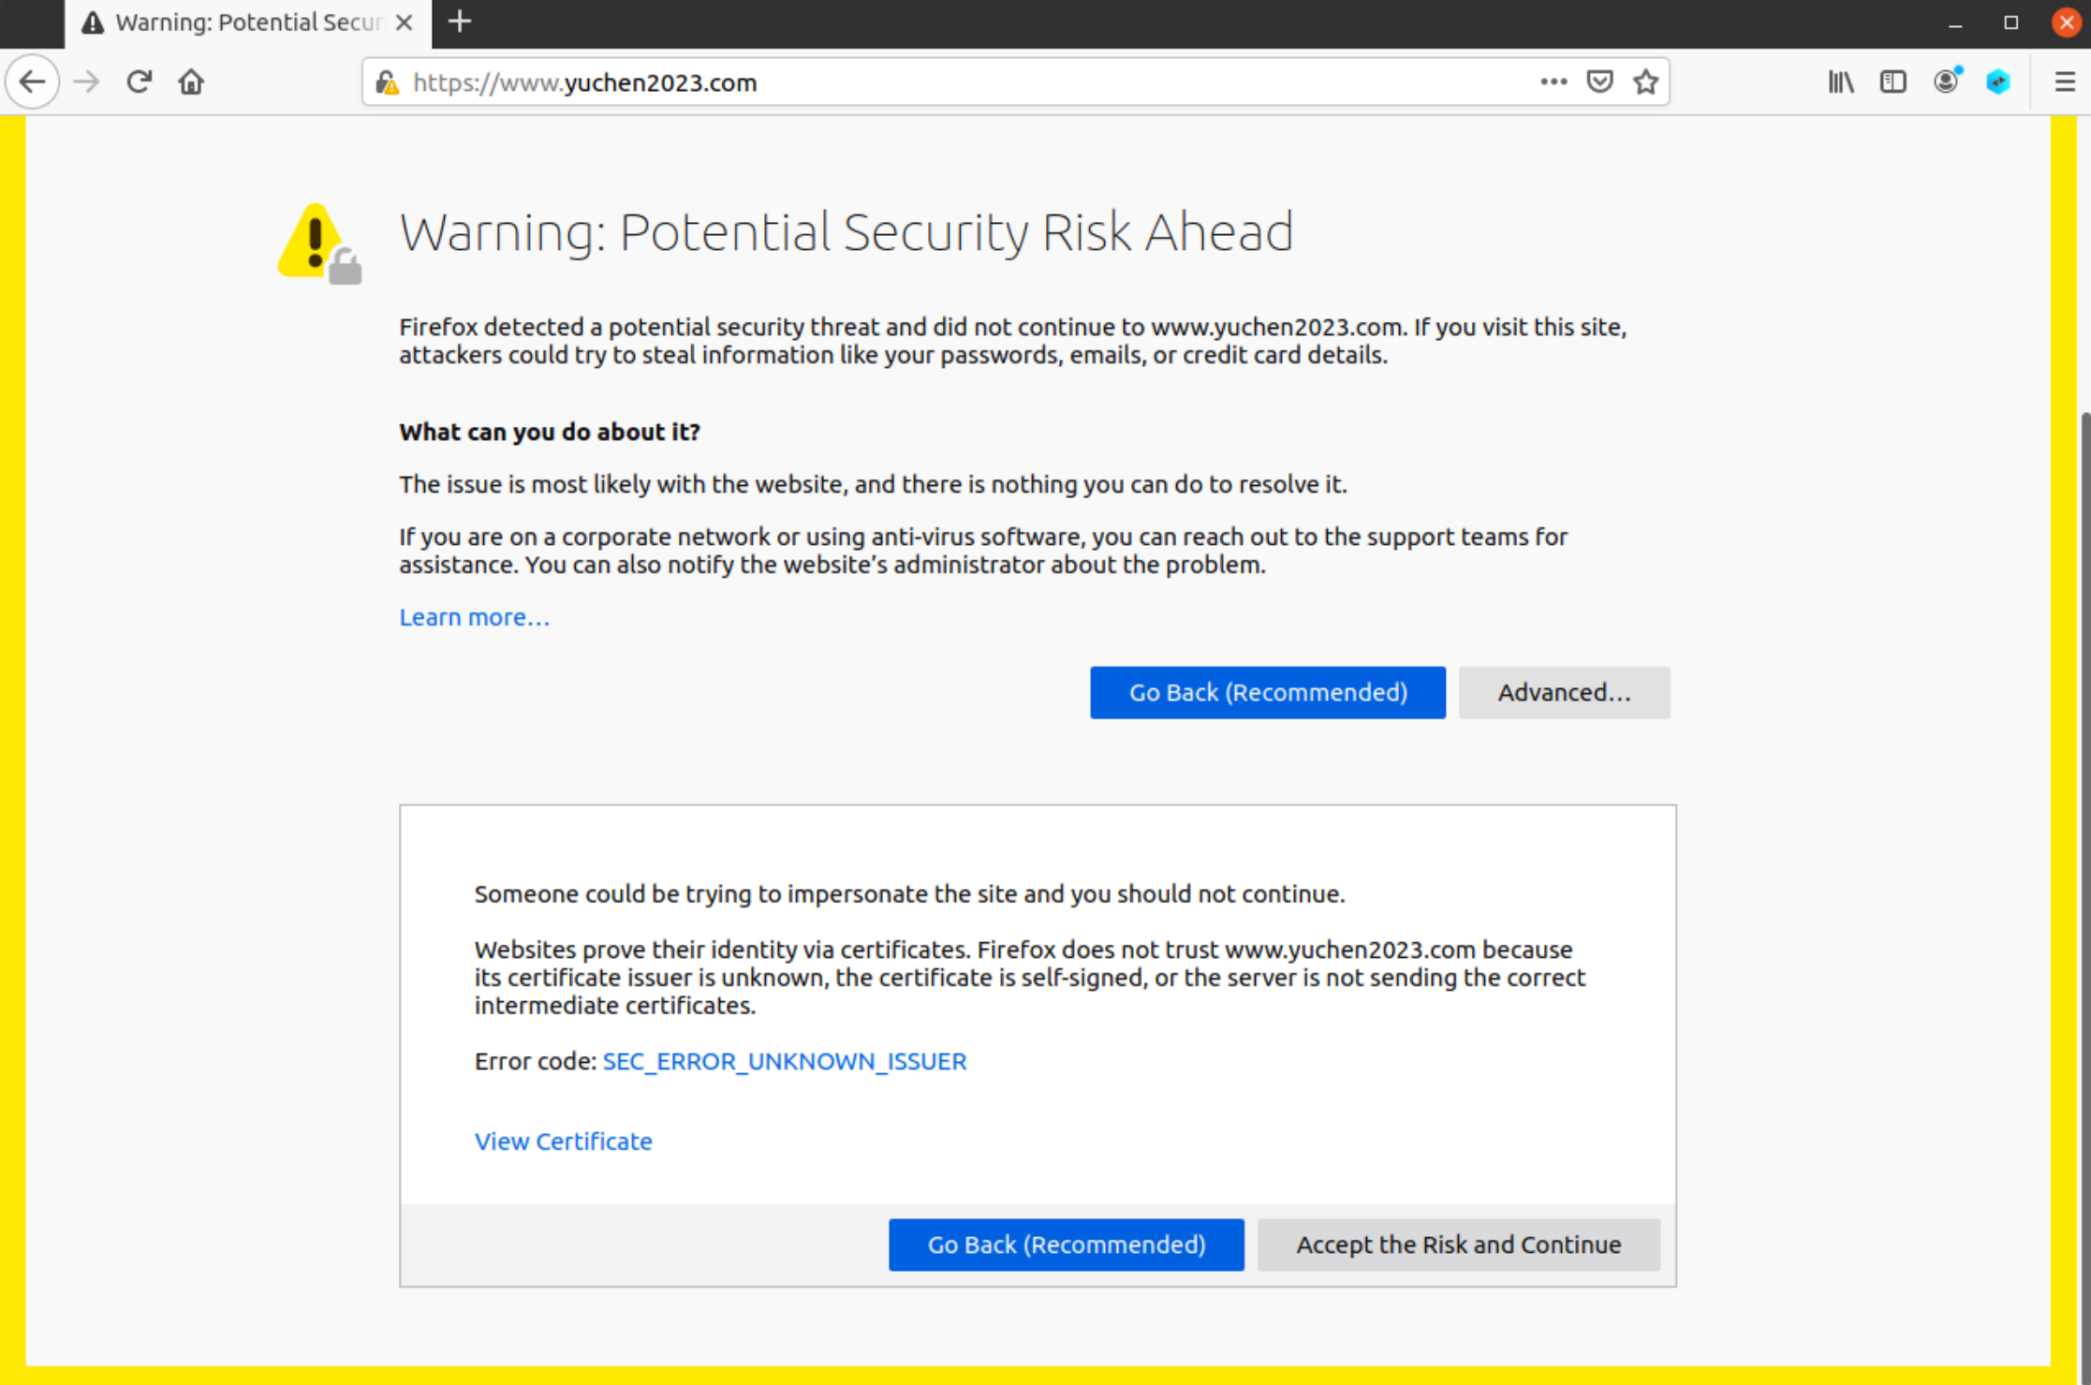

After clicking “Accept the Risk and Continue” , the intended page for port 443 is shown:

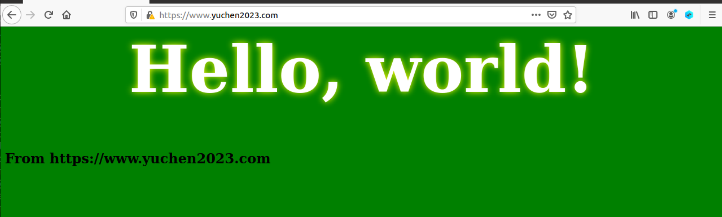

This is because the server’s certificate is signed by our root CA, which is not trusted by the browser. Thus we need to upload the self-signed certificate of our CA to tell the browser that this CA is trusted, and the websites who use certificates signed by this CA is also trusted.

So we import ca.crt in the Certificate Manager in Firefox:

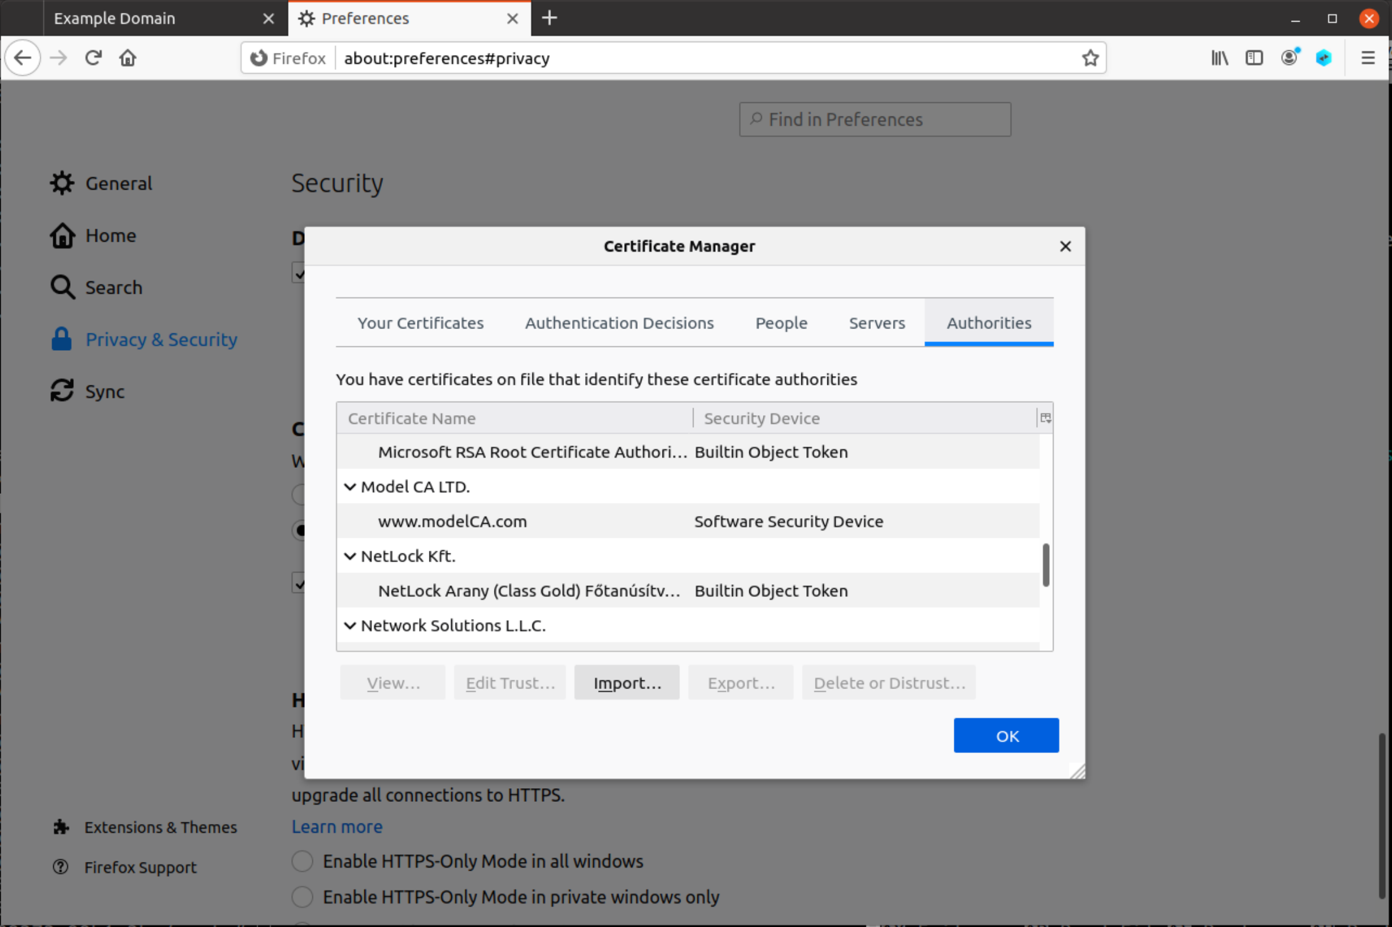

After importing ca.crt from PKI, the web is considered to be safe.

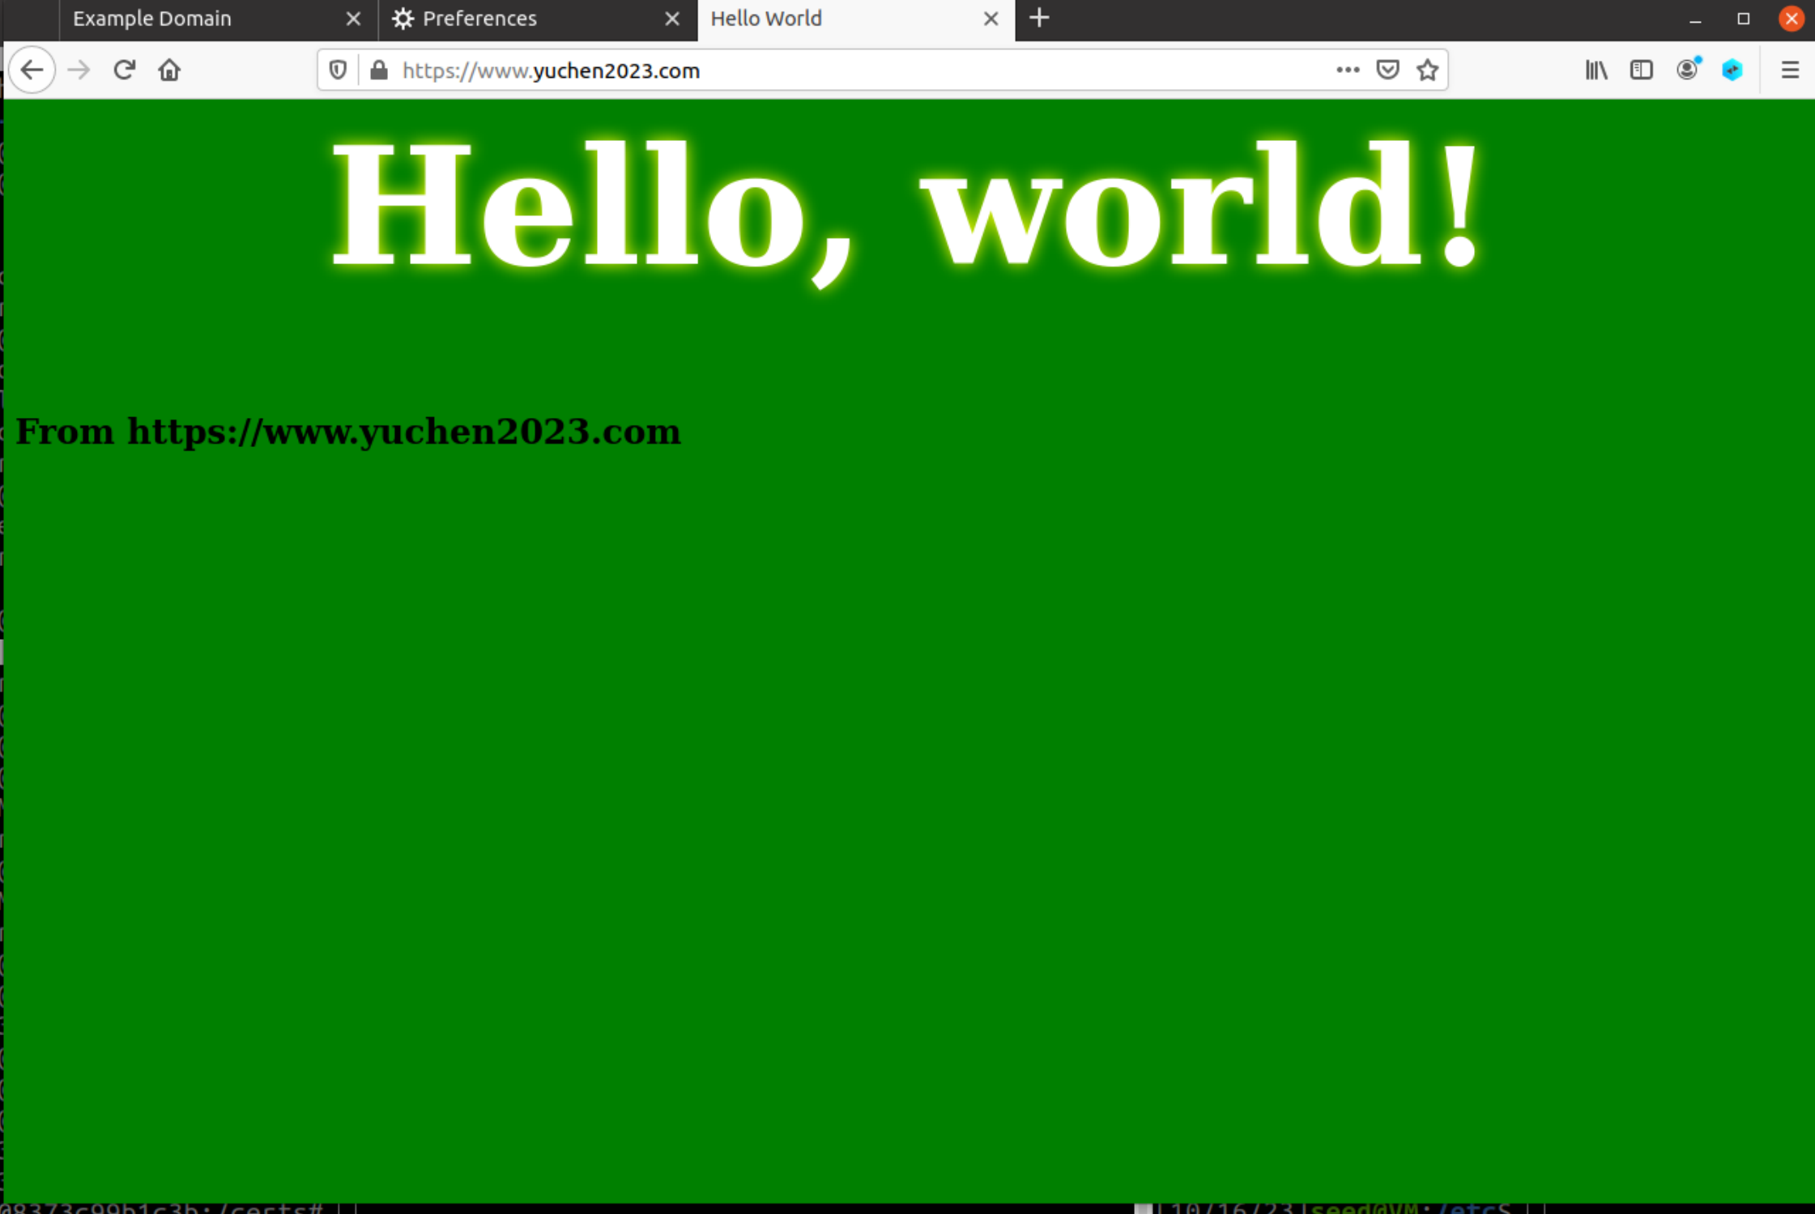

## Task 5: Launching a Man-In-The-Middle Attack

Similar to task 4, set up the configuration of [www.example.com](http://www.example.com).

1. Create example_apache.conf file inside /etc/apache2/sites-available.

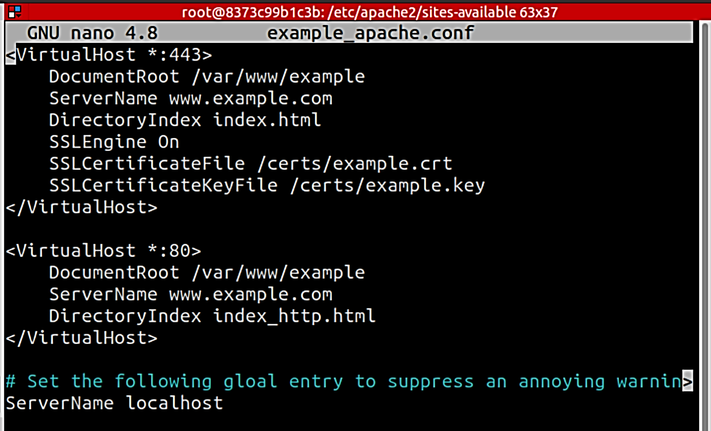

1. Directly copy yuchen2023.crt and yuchen2023.key to be example.crt and example.key.
2. Add DNS entry to the /etc/hosts in the victim machine.

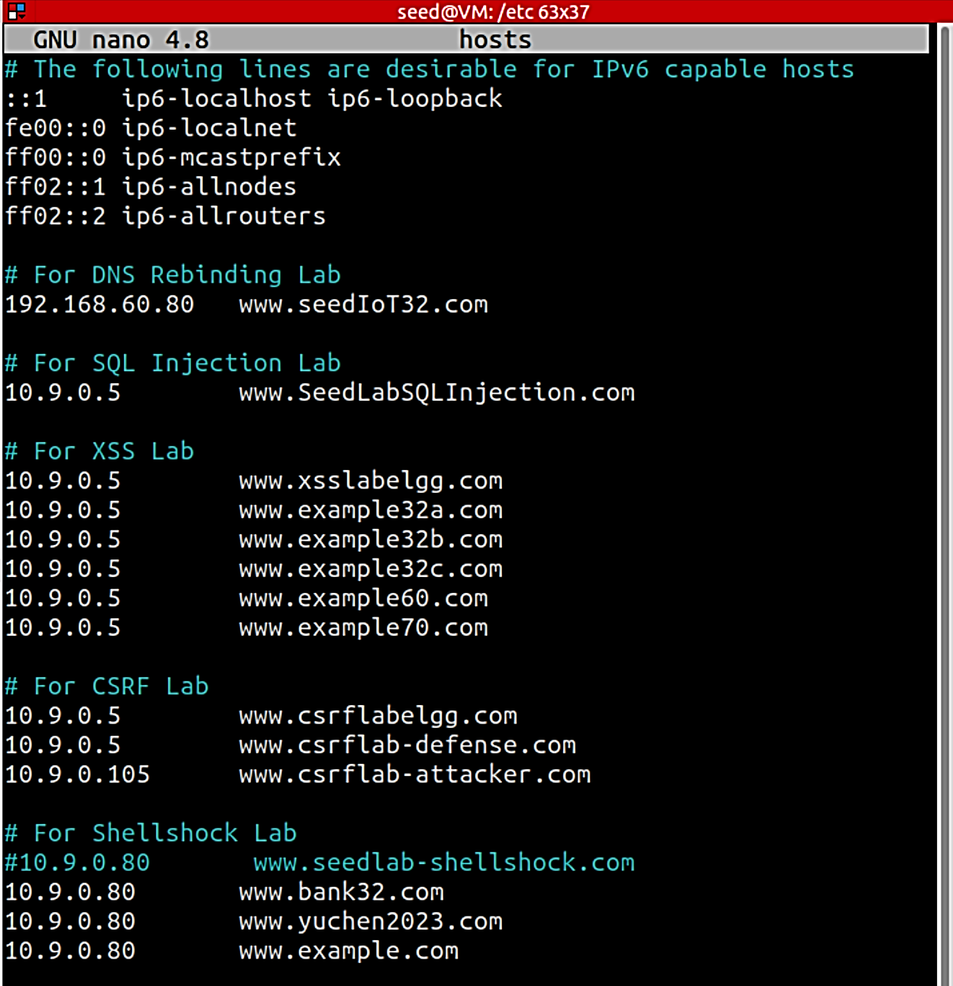

1. After setting everything up, visit <http://www.example.com>

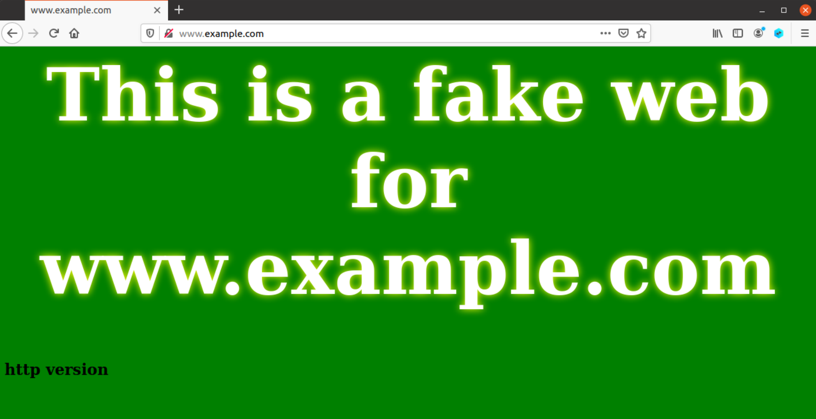

Visit <https://www.example.com>

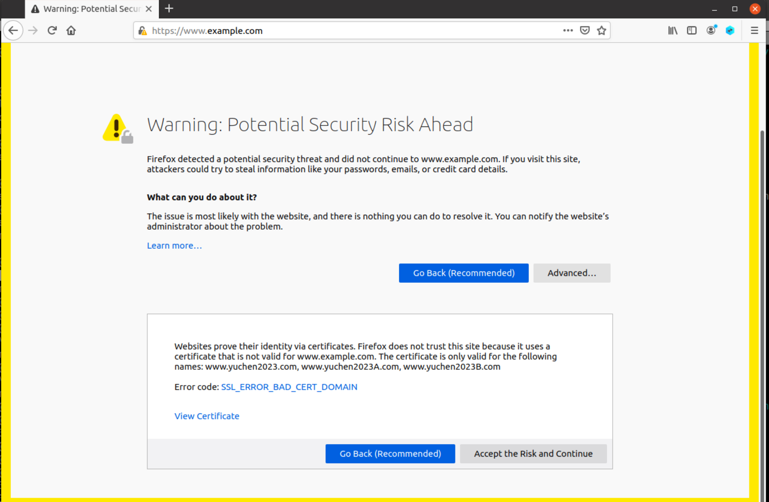

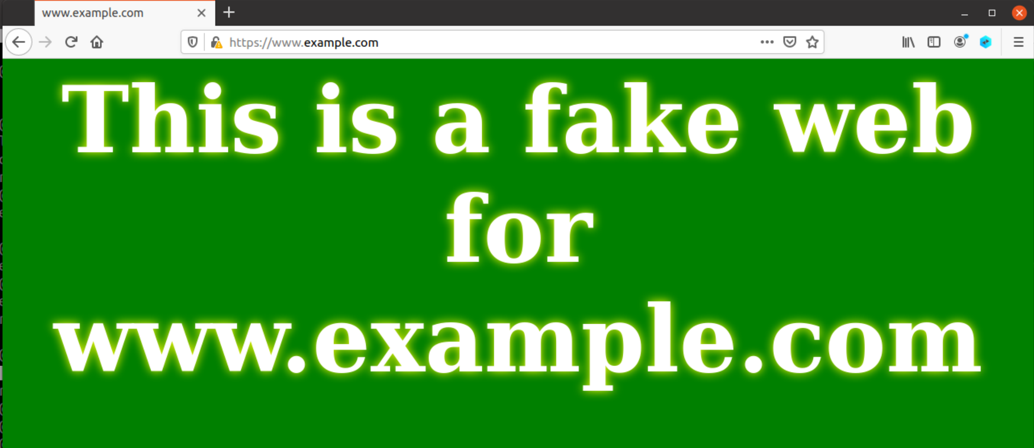

The error is caused by an invalid security certificate being used, with the specific error code of SSL_ERROR_BAD_CERT_DOMAIN. This is because the certificate used is for [www.yuchen2023.com](http://www.yuchen2023.com), instead of [www.example.com](http://www.example.com) that we are visiting.

## Task 6: Launching a Man-In-The-Middle Attack with a Compromised CA

Since the attacker gets CA’s private key, i.e. ca.key, they can sign certificate for their fake servers without contacting the real CA:

# generate csr  
$ openssl req -newkey rsa:2048 -sha256 -keyout server.key -out server.csr -subj "<SERVER_DOMAIN_INFO>"   
  
# sign certificate  
$ openssl ca -config openssl.cnf -policy policy_anything -md sha256 -days 3650 -in server.csr -out server.crt -batch -cert ca.crt -keyfile ca.key

Take [www.example.com](http://www.example.com) as an example:

Generate server.csr and sign it:

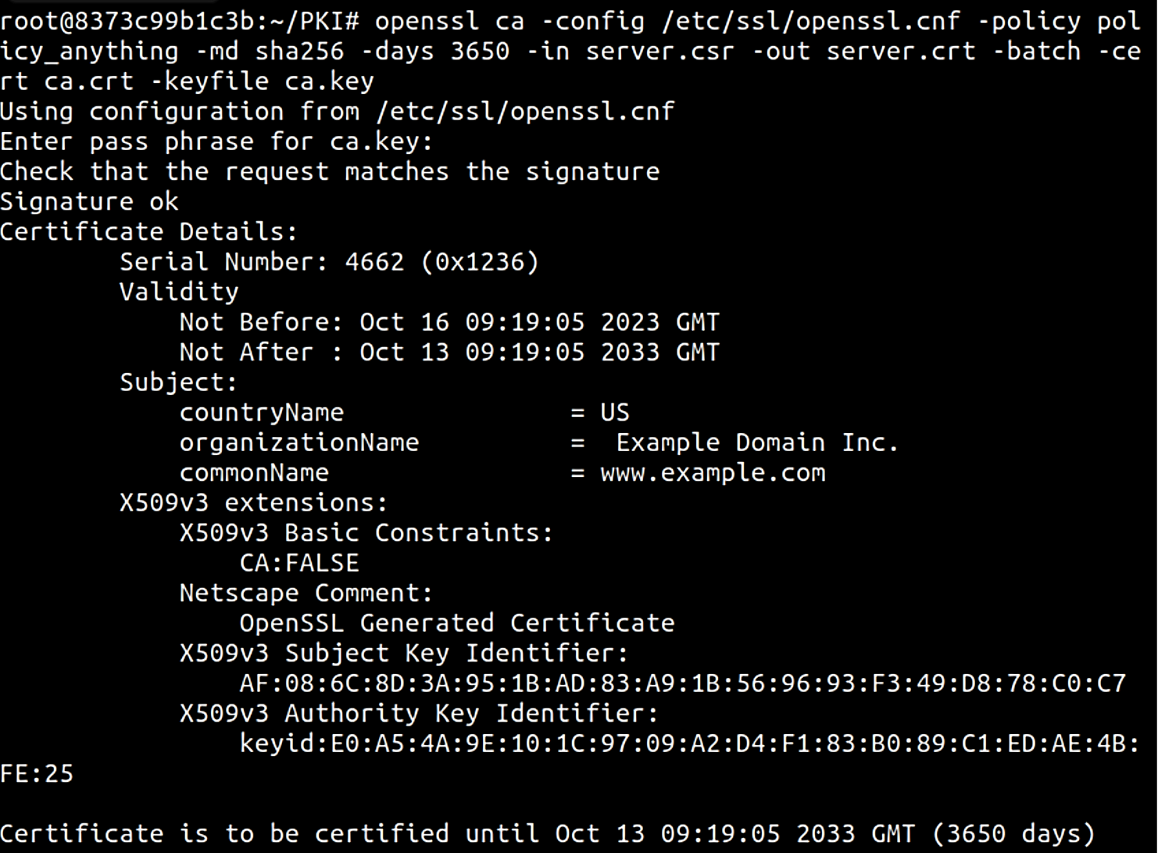

Use this crt and key as example.crt and example.key, which are defined in the virtual host

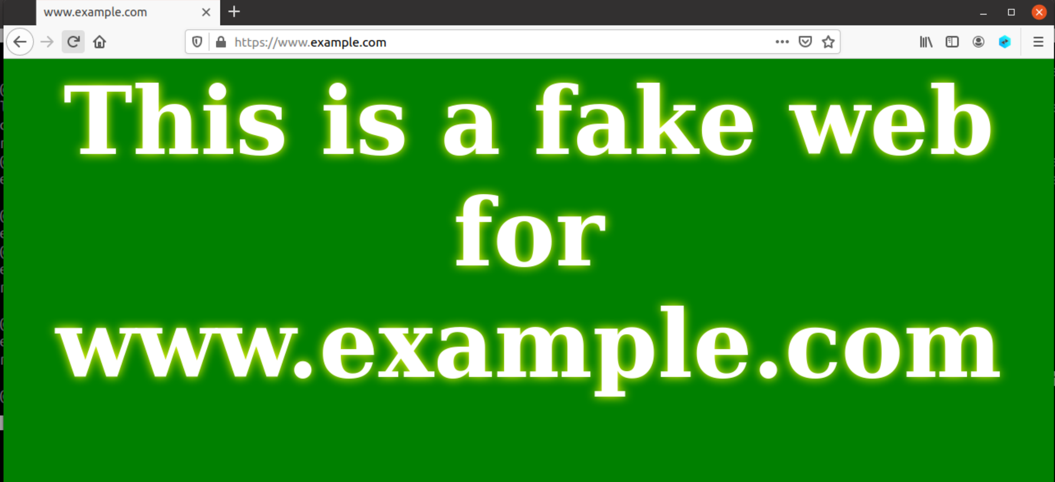

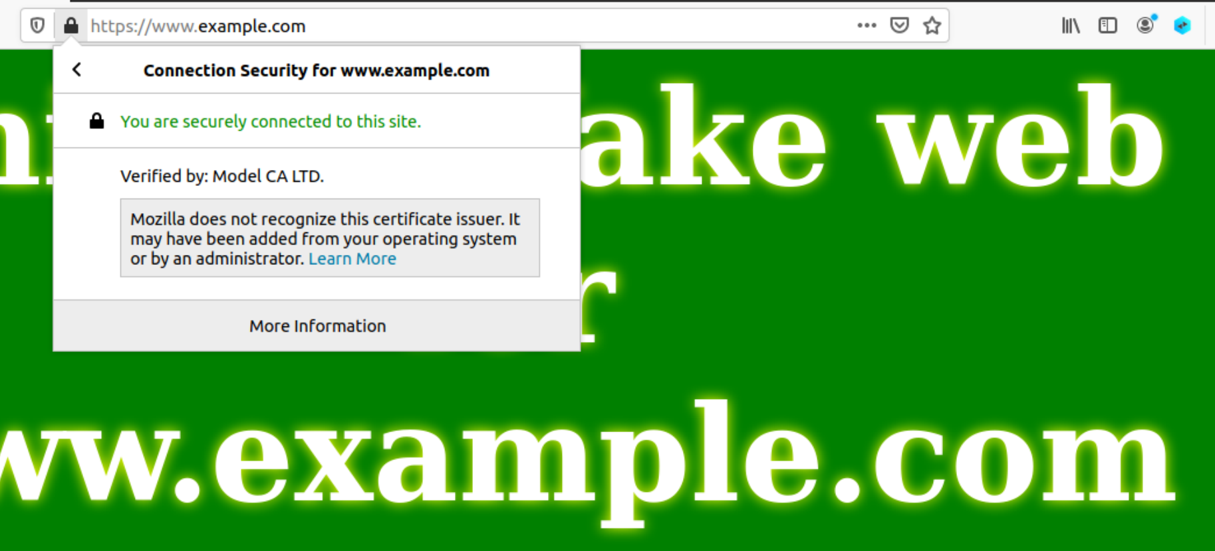

No error pops out since the domain name matches.

## Appendix

1. ca.crt

Signature Algorithm: sha256WithRSAEncryption

68:7c:8e:79:a5:11:ab:af:63:ee:05:c8:5f:b3:c1:d3:bd:bc:

fb:a4:82:b7:a4:6f:35:1e:09:6a:c2:07:b1:c2:1e:3c:36:a2:

f2:1e:34:1e:90:45:0d:52:9e:c6:21:0a:dd:76:9b:41:e1:2f:

9a:9c:72:8a:ee:2d:af:71:b7:48:bb:f1:97:f5:5d:58:e4:37:

18:61:a1:7f:0b:12:a6:a0:00:9c:c7:74:d4:2e:e7:83:74:93:

a1:c0:ab:fc:bd:ec:64:88:92:c1:9d:d8:41:eb:6a:63:15:4e:

1e:ec:f9:18:60:75:b5:2e:e0:43:97:5f:b1:ca:9a:e8:1b:d2:

ed:5d:94:7c:25:6a:97:67:0c:24:e6:d0:7d:c2:6d:fe:22:e3:

86:a5:f9:07:89:c1:18:d6:5a:bb:ac:c8:5a:a9:d0:37:2e:90:

c3:14:ea:dc:15:3c:9a:f4:80:a3:e3:be:30:25:92:34:39:aa:

51:ff:b1:3b:e0:03:05:e8:b5:76:1a:d0:db:78:96:2a:28:d1:

66:d9:f3:77:ff:0b:d7:62:e9:3e:7b:13:f6:0e:b9:3a:21:de:

e1:c0:b7:5b:7d:b3:48:94:2c:ed:53:4c:e0:50:c8:d3:8b:ce:

a5:c6:8c:4e:ed:0e:c0:69:aa:d6:b8:2b:ad:f9:b1:6b:7e:f0:

66:3d:db:7b:e1:a4:8d:77:1c:64:31:53:31:90:fc:49:43:13:

1e:94:43:e7:c2:52:ac:74:fa:29:4c:9c:23:06:71:70:13:61:

1a:4f:00:0a:2d:ed:10:3d:4d:54:37:d1:30:1c:db:e1:55:74:

16:7a:f2:9c:4d:16:c7:14:6e:e7:d7:8d:68:40:05:ff:2e:c2:

49:31:f2:d1:ea:5b:a9:28:9b:79:df:6c:d6:87:01:c2:80:4f:

a1:3a:09:02:c1:12:9f:1e:19:b6:08:73:ed:8e:c9:4e:a6:a1:

96:ef:df:3f:57:84:8a:dc:20:20:9b:9e:1a:c4:cf:4c:04:22:

c4:ab:c2:81:82:6b:aa:d8:ee:c7:ea:12:03:39:50:e5:7d:ad:

4a:b9:6b:71:b0:46:37:4b:56:6c:2a:ac:6d:7f:1c:7e:8e:d9:

3c:e4:c4:c5:75:73:56:1c:d0:03:f6:ae:9d:09:8a:76:0b:1e:

b6:2c:a3:d9:ca:2f:7f:33:58:45:34:cb:b7:3f:ab:ad:d6:52:

3c:2b:36:77:4c:f9:ea:22:3e:4e:02:af:04:31:e0:de:30:c3:

d9:11:ad:5a:92:0e:0c:7a:e7:21:f4:e4:1a:c5:5d:b5:30:7a:

a8:c2:c3:21:53:05:ff:32:71:77:aa:e6:34:83:ec:59:29:87:

17:b4:b6:15:73:3d:2c:d3

1. ca.key

RSA Private-Key: (4096 bit, 2 primes)

modulus:

00:b3:c7:0e:92:b7:c2:47:08:46:14:8c:4f:e2:e6:

41:90:b7:cc:32:20:49:2e:5c:59:6e:86:2f:e6:a3:

40:a6:a1:82:53:c2:dc:97:66:48:b4:e7:44:2b:bc:

3e:85:1e:a2:84:24:bf:6b:10:2f:17:5b:4c:e7:98:

fa:0b:d8:9f:2d:8d:7e:f9:76:2d:41:75:ac:86:ed:

81:28:95:c9:8b:90:a0:95:c6:a7:8a:ce:d9:78:b8:

f2:b3:d4:30:d8:84:5e:9e:68:6e:28:07:a8:c4:66:

8d:8e:a1:02:91:17:b0:30:98:6d:6d:d4:64:30:16:

f3:27:d8:28:57:09:dd:d6:32:91:b2:3b:b5:6f:0b:

15:88:d0:a2:4f:89:63:e1:33:51:6c:0f:62:03:83:

8f:2c:d3:b3:8f:bc:99:81:66:a2:b8:c6:28:4e:2d:

cc:f3:3a:42:12:4f:ee:12:03:d2:f0:44:46:b1:cb:

01:ae:36:57:9c:23:8e:54:4f:62:e7:c5:1a:25:d2:

2e:cb:d2:b6:36:82:50:7c:55:64:90:cb:b3:ea:b0:

b8:a4:af:65:36:0e:b9:c0:05:39:12:53:03:89:00:

b2:40:2b:36:0f:b8:30:cc:95:2f:37:f0:ca:30:79:

c8:66:40:6c:b5:43:7c:cc:29:5c:a9:9d:63:9e:9b:

c3:23:21:d2:02:89:ea:17:33:c0:b0:cc:53:08:95:

5f:bf:ea:9a:65:9c:a6:96:cc:8a:b0:69:6c:2c:9b:

02:b0:fc:dc:3a:a9:53:2f:ec:0f:d7:70:af:67:fc:

37:b4:88:ec:00:12:92:4b:2d:d1:81:a8:ed:46:a2:

86:56:cd:08:03:5c:38:3b:30:09:43:23:09:8b:79:

4a:99:44:69:91:f5:d0:75:72:5a:31:09:37:9a:23:

28:33:3c:95:38:97:1c:12:66:1d:ba:71:68:38:20:

52:d8:75:d7:b6:09:39:f8:d2:37:ab:45:9c:b2:89:

3c:cf:40:ed:39:16:9b:c3:67:97:93:c0:37:16:69:

c3:51:ce:a9:7f:26:46:24:1c:49:9d:ee:e1:71:ac:

c9:f0:94:3c:f2:24:78:5b:cc:00:fc:e8:c9:f2:25:

dd:74:b9:15:51:24:ec:db:f2:34:eb:f8:58:85:51:

c5:bb:a7:55:c7:80:19:66:c5:99:06:24:4b:56:28:

66:66:63:9f:98:08:71:d7:62:44:be:2e:81:8f:02:

d2:9d:d3:4d:bd:52:b8:79:af:2f:0e:e1:c9:eb:b2:

e6:43:c2:83:29:fc:6b:23:1a:24:8d:3f:4f:f8:a9:

20:fa:a0:01:58:65:11:a8:99:c5:af:5c:a5:10:5e:

97:ab:0d

publicExponent: 65537 (0x10001)

privateExponent:

1b:81:6a:26:62:7d:13:f7:1d:19:c9:b9:f3:42:3d:

67:d1:e7:29:08:2d:8a:2d:50:f5:8b:0c:4b:22:51:

22:ed:75:0e:31:b3:24:6a:de:d6:e6:c7:54:55:b1:

cf:16:37:d1:35:fa:1f:7c:53:68:24:6c:e8:c6:4c:

03:81:fa:20:b3:14:69:40:7e:7e:14:6d:f8:1a:e0:

77:00:2b:dc:f1:9c:d0:2d:9b:b6:ae:1d:31:ce:42:

3b:e7:4c:2d:e4:5a:c1:ab:c2:a6:d7:3d:28:07:74:

c3:0c:b9:62:cf:98:02:67:5f:de:bc:ef:33:38:5f:

ad:89:f1:ea:17:35:5c:af:52:01:4e:07:5d:5c:f9:

c7:7b:fc:49:65:00:e6:14:be:f1:64:8d:1f:72:82:

76:5e:51:8b:bd:54:53:2b:0b:dc:6f:5c:fd:51:1e:

99:5c:21:7d:c1:c2:ef:f8:ab:ce:5c:f3:e0:01:ea:

58:e8:31:91:4f:13:58:ac:e8:ba:03:3b:13:ec:4b:

82:9d:d3:89:15:79:10:fc:d3:ad:1f:ad:80:4b:d7:

84:42:dd:9e:5e:b4:66:bf:a5:d2:ba:e6:c0:90:5d:

b5:59:a7:24:d2:8e:8c:ce:8a:71:e9:a2:55:b6:5c:

45:e0:b7:81:28:39:30:d7:67:39:00:3e:9c:a6:c2:

3d:1d:24:98:4c:8e:1d:cf:f1:bb:55:f7:28:06:40:

78:f0:cc:d6:57:f3:06:1c:6b:4c:8d:38:7a:68:48:

c4:a0:a7:cb:c5:ba:4b:62:39:45:cb:b7:6e:93:3b:

c6:cb:f7:bf:19:22:6a:36:a8:52:b8:60:2b:5e:01:

5d:27:d5:6b:d2:ab:86:0e:3c:38:d4:54:d8:c9:e8:

6c:38:95:1a:c6:f7:7a:ad:d4:20:5d:ea:18:0b:f2:

07:8e:ad:35:db:9c:81:b5:56:be:86:79:35:d3:c2:

00:ee:92:fd:b5:6c:94:72:82:af:18:35:48:ef:49:

43:8a:e2:b1:9a:e8:1e:8e:5c:b0:74:46:7d:49:c4:

bd:63:aa:08:b6:3a:27:78:93:83:ed:9a:06:f5:01:

17:8c:34:45:e8:c4:6f:34:f5:c0:5d:95:ce:4a:a2:

5c:dc:53:01:92:67:ed:6a:f8:87:ae:ed:9b:7c:02:

69:7b:48:33:31:59:ba:b9:08:64:0d:6f:8c:b4:3a:

87:c4:bb:89:7c:8e:e1:00:ff:b7:cc:3b:02:17:d4:

a5:92:27:6e:79:38:c3:39:b8:b0:e9:49:11:79:38:

67:6c:26:25:c0:6e:85:35:87:b7:fd:89:74:67:ac:

cb:b5:6b:19:ed:8a:d9:5d:8d:71:29:d6:1d:d3:29:

bf:b5

prime1:

00:dc:9c:c9:dc:0e:55:c7:23:9d:96:ca:57:d0:f7:

92:27:b5:e6:dc:4f:e7:5f:7f:40:76:d2:83:fe:a0:

9a:20:49:26:41:81:e7:71:c5:6b:c4:2e:28:c3:e6:

79:22:d6:30:72:88:49:b5:14:1f:68:c3:ae:38:de:

69:4e:59:60:a6:67:b9:21:3e:40:ef:bb:f2:9b:39:

f1:2d:89:2a:58:30:af:b9:49:90:bf:fc:76:e4:18:

aa:70:ed:f6:6e:5a:ca:4d:d1:b4:f8:ad:b4:b3:c1:

7e:bf:6d:ca:53:bb:9f:01:be:f9:19:8f:6e:10:37:

ba:01:8c:dc:95:19:09:6f:39:58:0a:d8:bc:c7:b8:

4b:fd:93:6e:a9:38:57:ba:d1:27:e9:ef:43:f2:f0:

49:a1:c2:cd:5e:aa:b0:48:32:d2:c0:f1:e5:32:b9:

ee:6f:d4:3e:10:17:71:92:ce:a1:8d:93:93:71:75:

63:41:cf:43:25:49:25:7e:0c:a2:e3:d2:b4:02:bc:

7f:94:68:5d:8f:35:03:2e:20:6b:da:be:5b:e7:17:

d5:4d:f9:11:7d:3e:60:d5:a9:1b:e0:8b:c9:ed:9b:

4a:7f:fc:71:2a:48:6e:a0:d2:be:ff:52:ee:5e:c2:

bb:49:60:8c:1e:0c:45:29:56:71:e0:85:df:cf:f1:

10:b3

prime2:

00:d0:9d:6d:8c:d6:0d:81:5b:3f:b1:24:8e:d3:75:

24:c4:74:a3:cd:66:b1:12:fc:73:88:c5:f0:62:7f:

ef:f7:8c:d0:4d:02:18:7d:d9:2a:0f:2d:37:7e:1c:

3a:90:11:e7:31:80:83:17:4c:ae:15:e9:50:90:57:

a7:68:33:3a:28:7d:be:4a:ae:8a:30:b5:0b:c3:74:

cf:ca:3f:e1:ba:9e:f0:5a:18:27:1d:54:d2:ab:56:

03:46:8a:51:6e:6b:83:bd:4a:ed:50:4b:4a:d9:1a:

ca:c6:5f:65:0c:2a:06:66:ec:35:67:8e:17:f5:1f:

0d:6e:66:0a:d1:12:8e:81:07:95:e2:95:e4:2e:f9:

4c:d5:77:7b:3a:2a:7a:3a:89:38:d8:09:ba:c2:3f:

a9:01:f4:1a:47:43:3d:bf:2a:87:1b:0c:6a:fe:b6:

92:23:fb:74:37:70:e7:7a:3b:ea:fe:eb:2e:09:86:

0c:d5:1a:b6:75:4a:8c:03:d6:4c:47:3f:42:f2:8b:

64:5d:50:58:6b:49:cf:54:92:cc:b9:75:2b:1f:07:

9f:1d:51:2e:d7:b7:b7:b7:98:36:9c:99:8a:0e:c6:

3f:2c:e3:0b:79:c3:fe:6f:a5:26:bb:ee:2e:be:dc:

7d:1e:3c:1e:c0:7a:5f:c7:2b:21:6b:4a:2a:c7:b2:

b5:3f

exponent1:

52:dc:f1:55:1e:6d:49:a7:2f:01:fc:6e:8f:a6:ed:

d6:cc:94:32:1c:31:23:c5:80:49:21:39:42:e2:c0:

01:70:78:56:12:9d:04:36:cb:0b:9c:ea:e2:ea:26:

85:d7:3d:cb:47:35:a8:36:2e:b6:03:09:e5:82:64:

bb:71:06:c4:7a:21:27:43:62:d0:a9:1f:ae:fe:4c:

80:76:0c:d9:a3:2f:dd:c0:ac:05:f0:a6:17:76:cc:

4e:2e:93:69:4f:e0:bc:ea:0f:b7:78:47:6f:5d:36:

66:60:ae:a6:54:ca:9c:b5:46:8b:3b:3c:74:0a:fa:

6a:aa:a6:0f:ba:9f:b8:8f:29:6a:a9:8d:fe:d6:52:

74:a4:73:e4:4b:ad:68:16:37:8f:be:b7:1f:00:f2:

27:38:2c:3b:6a:91:5c:0c:fa:ec:4d:ef:70:e6:35:

90:fb:7f:74:3b:da:04:f2:67:eb:ed:8a:6c:0b:53:

84:dc:7c:b3:fc:8d:80:92:ee:7b:f4:20:79:06:a4:

44:f2:0e:72:43:cf:35:fc:27:86:ba:09:7a:fb:90:

bb:00:da:78:d8:7d:36:c3:96:1c:f9:64:97:42:c4:

f0:dd:b9:03:d0:c0:fc:d7:2b:b6:6b:47:ed:7f:e7:

28:e0:82:c0:a6:8b:33:c3:ac:72:50:d6:88:1c:5b:

d1

exponent2:

34:7f:f9:ea:e0:8f:a3:87:40:3f:27:51:1e:5c:33:

b5:91:19:0b:ff:14:ff:0f:33:50:2f:68:30:91:bb:

e5:53:b5:b4:3b:9b:c8:48:17:b2:9c:11:84:16:3c:

92:b7:3e:b4:91:7f:ec:24:2b:07:6e:a1:0c:c2:52:

6a:01:c2:58:20:54:fc:5c:72:80:91:7f:75:5f:f7:

4f:11:c6:8f:fd:a1:c5:3a:a0:d5:5b:dc:6c:ac:07:

c4:ff:d8:40:6e:a4:47:c6:0c:75:11:8d:b3:97:6f:

82:7e:cd:62:43:4d:3b:27:a4:c4:fb:d8:81:a2:9f:

f1:b1:92:75:4d:33:39:bb:9b:f7:da:fb:02:eb:50:

6f:c4:52:e9:af:78:f5:34:45:6e:f0:fb:e4:18:bb:

42:b7:98:c9:68:5d:a8:b7:5e:2a:eb:74:1d:c7:fa:

7d:3d:b1:e0:a5:f4:4b:29:bb:19:0e:3c:96:be:fa:

89:c2:e0:3a:22:59:9c:39:99:16:b1:0f:fb:14:23:

5c:ec:74:64:03:be:3e:ad:77:02:11:3f:99:de:84:

27:8f:9f:b7:40:0f:e7:0f:52:67:14:a8:ce:d1:0b:

63:13:7c:76:d7:61:37:dd:9b:22:de:6d:3b:31:27:

f7:ac:ef:9c:46:ef:c5:a2:d0:15:3d:24:08:ff:ab:

67

coefficient:

00:bd:5d:58:a8:75:3a:79:8d:01:06:90:80:de:57:

6d:9e:69:fc:46:62:ca:24:85:a1:0a:9c:6a:2f:b6:

65:40:f5:e9:15:30:41:1d:5f:41:e4:c2:7a:73:1c:

53:52:4e:8a:ad:0d:0f:f9:66:49:14:d7:fd:32:9e:

8e:1e:ed:56:2c:88:ac:9f:97:4b:ca:a0:c4:f6:e8:

7f:99:a4:94:1f:3f:75:ca:7f:1b:6b:69:bd:c5:ee:

50:01:76:9d:ab:5d:a3:36:7c:0a:01:14:71:06:7b:

0b:4a:80:66:24:36:56:36:dc:33:a8:2d:b4:ea:d0:

f1:58:05:da:dd:b8:8b:fe:e3:b7:ae:dc:18:2d:1c:

24:73:dd:40:19:14:11:c7:aa:01:9e:2d:ec:2a:cc:

77:09:48:c6:fa:b9:55:f6:76:0c:a6:a4:d3:a1:ea:

04:3f:ac:10:ad:69:9d:0d:7b:6d:ed:43:b5:c9:bf:

0f:62:78:62:18:87:f4:60:1e:9b:6e:cc:ab:0a:9d:

6d:98:75:59:e3:9a:64:aa:b5:5d:b9:80:c3:e5:e7:

20:ee:45:9f:d5:d9:db:34:97:16:96:ec:8e:39:08:

9e:89:b4:4d:bf:14:2f:ba:c4:ec:ff:90:58:62:4d:

20:80:04:16:9c:6f:d8:02:a6:59:45:41:85:69:ca:

2c:4a

1. server.csr

Certificate Request:

Data:

Version: 1 (0x0)

Subject: CN = www.yuchen2023.com, O = Yuchen2023 Inc., C = US

Subject Public Key Info:

Public Key Algorithm: rsaEncryption

RSA Public-Key: (2048 bit)

Modulus:

00:bc:1a:df:63:2a:8c:5f:99:a5:92:f5:02:b2:7f:

f8:bc:18:f9:31:23:aa:c5:60:2d:07:a4:5c:38:fc:

66:f2:8d:ac:d1:a0:89:84:e2:39:fb:4e:d8:97:48:

94:ad:26:40:92:b0:82:c5:cc:4f:77:a2:70:fb:03:

31:75:47:65:c0:3a:10:43:f5:18:6f:02:5d:09:8e:

a4:b8:00:9b:9b:a5:c4:0e:64:89:ce:2f:00:a2:c8:

54:9b:8b:68:b3:44:96:67:7e:61:80:c4:58:ad:62:

71:24:30:a1:ce:c8:b0:b5:a7:5e:4d:e1:fa:9a:19:

fe:46:cd:69:5b:bc:98:74:c4:d5:be:cc:e6:48:e8:

13:0e:99:ed:e9:74:59:41:ab:99:fc:19:e2:70:31:

83:d1:e5:93:93:6b:c9:ff:f2:07:eb:24:25:3e:f3:

9b:2a:ec:51:7a:c1:f3:3f:77:a2:0e:bf:d4:4f:0c:

78:99:9b:2e:8c:14:29:25:8f:c2:b3:80:3d:02:b9:

20:26:dc:e7:ed:4a:d3:68:4f:01:25:2e:54:26:db:

95:98:38:1a:37:ce:8f:15:97:22:94:8d:1d:92:35:

17:47:7f:e5:05:30:c5:0b:bf:3f:b5:11:cb:30:af:

40:74:7f:87:2b:52:a4:29:5b:31:2c:37:c1:13:12:

f0:3f

Exponent: 65537 (0x10001)

Attributes:

Requested Extensions:

X509v3 Subject Alternative Name:

DNS:www.yuchen2023.com, DNS:www.yuchen2023A.com, DNS:www.yuchen2023B.com

Signature Algorithm: sha256WithRSAEncryption

ba:9b:7b:4b:fa:9f:cb:85:32:a4:f9:73:2b:49:1b:7f:a7:0e:

ef:bd:6f:6f:a0:f9:e8:24:65:f9:ee:79:24:ca:ce:f1:0a:12:

19:1d:91:d6:2d:07:88:d0:c6:85:b5:a1:54:80:8e:6e:05:83:

8a:80:df:fd:fa:99:5f:f8:6d:19:f0:42:a7:d3:e9:75:38:a1:

ad:3a:c8:0f:82:32:f3:e6:74:ee:84:73:cb:44:21:1e:40:e1:

9c:7f:1f:45:94:7f:b8:a8:61:bb:ec:75:17:a1:9f:68:ab:44:

2a:ea:f8:ad:9f:8e:63:4b:27:74:a3:90:b0:d3:c3:75:24:a5:

fe:72:51:35:ad:f6:a4:d0:46:60:32:52:ef:f5:f7:63:6d:61:

59:61:ed:56:ab:ca:0b:a7:90:36:ca:91:27:24:00:d7:36:be:

98:c8:56:9f:70:1b:ba:42:2a:77:92:60:cf:d0:59:62:35:e8:

95:ac:fa:fe:92:84:3b:3c:dd:6f:19:2a:c6:eb:8b:cb:e8:19:

35:3d:64:b0:61:27:7f:7d:d0:80:48:b2:1c:f1:c0:34:57:ab:

08:ad:cb:9b:b5:40:c4:44:e2:83:4f:79:27:44:34:85:6b:77:

29:18:72:6d:22:6a:02:86:ee:01:81:96:a1:cf:1a:26:fc:14:

0f:64:75:3a

1. server.key

RSA Private-Key: (2048 bit, 2 primes)

modulus:

00:bc:1a:df:63:2a:8c:5f:99:a5:92:f5:02:b2:7f:

f8:bc:18:f9:31:23:aa:c5:60:2d:07:a4:5c:38:fc:

66:f2:8d:ac:d1:a0:89:84:e2:39:fb:4e:d8:97:48:

94:ad:26:40:92:b0:82:c5:cc:4f:77:a2:70:fb:03:

31:75:47:65:c0:3a:10:43:f5:18:6f:02:5d:09:8e:

a4:b8:00:9b:9b:a5:c4:0e:64:89:ce:2f:00:a2:c8:

54:9b:8b:68:b3:44:96:67:7e:61:80:c4:58:ad:62:

71:24:30:a1:ce:c8:b0:b5:a7:5e:4d:e1:fa:9a:19:

fe:46:cd:69:5b:bc:98:74:c4:d5:be:cc:e6:48:e8:

13:0e:99:ed:e9:74:59:41:ab:99:fc:19:e2:70:31:

83:d1:e5:93:93:6b:c9:ff:f2:07:eb:24:25:3e:f3:

9b:2a:ec:51:7a:c1:f3:3f:77:a2:0e:bf:d4:4f:0c:

78:99:9b:2e:8c:14:29:25:8f:c2:b3:80:3d:02:b9:

20:26:dc:e7:ed:4a:d3:68:4f:01:25:2e:54:26:db:

95:98:38:1a:37:ce:8f:15:97:22:94:8d:1d:92:35:

17:47:7f:e5:05:30:c5:0b:bf:3f:b5:11:cb:30:af:

40:74:7f:87:2b:52:a4:29:5b:31:2c:37:c1:13:12:

f0:3f

publicExponent: 65537 (0x10001)

privateExponent:

12:b4:85:64:42:15:e5:67:cc:fc:39:1b:04:8f:0f:

37:fd:2f:c2:80:2e:7a:24:1f:36:34:54:eb:61:c6:

06:f6:a9:a9:ca:d2:02:01:d1:0c:39:81:f6:41:44:

6f:97:6f:32:67:15:0a:00:50:22:b0:67:95:be:72:

8b:9c:06:f5:3f:90:e0:81:1d:e5:e4:11:46:63:05:

e4:3a:43:3f:0e:13:d9:ee:8b:79:92:58:f8:d6:fc:

fa:de:b9:11:a2:8f:66:49:3d:fe:e5:07:80:6e:5a:

9b:e3:ae:23:76:f7:83:88:da:2a:da:7e:e6:16:11:

a0:0e:cb:1c:51:3b:c3:d8:a6:f5:45:4d:bd:c6:46:

2a:16:5a:58:c8:e5:f2:e0:c4:48:02:2e:ce:07:42:

2f:ed:fe:2e:63:e8:a0:35:79:87:04:39:ac:41:ab:

11:23:45:1f:b1:8e:7a:1f:a1:63:be:7b:65:50:ef:

d1:29:bc:40:e8:80:75:bf:0c:fa:62:36:fb:fc:64:

f2:63:af:38:52:89:11:34:3d:c2:e4:68:f8:de:10:

d5:f2:0f:fb:d9:ec:de:ce:21:62:b7:1a:7c:ff:47:

35:bf:99:e7:27:a8:4f:b3:8e:a2:16:7b:bd:6c:82:

80:43:1a:ed:32:a3:b7:2f:f0:19:7d:fd:40:c2:45:

d9

prime1:

00:fa:9d:4f:d2:6a:6d:b0:50:80:bf:bb:aa:77:62:

53:5d:c2:9f:9a:06:2e:04:34:73:7b:bd:05:d9:e6:

96:91:bc:00:be:05:6a:9a:73:b7:39:fe:83:ec:90:

c1:da:c4:47:5c:1a:4a:5c:0d:d6:67:a9:41:17:02:

8d:1b:46:19:bf:47:88:70:bf:f3:e6:f0:4c:0c:d5:

c7:16:a9:ce:1e:3b:9a:06:62:d6:54:4a:12:db:9f:

b5:f4:f7:ea:7d:c0:08:cc:b9:8d:12:bb:f9:bd:17:

ea:86:43:ae:fe:8e:53:d6:6c:86:1e:84:f4:74:51:

cc:62:b3:99:cd:40:b5:1b:ad

prime2:

00:c0:25:ae:74:57:9f:6e:51:08:13:62:1a:39:66:

b8:a0:71:01:06:ec:45:17:3c:55:73:c8:04:7a:9a:

32:a8:7c:23:f7:22:76:9b:2d:fb:88:94:4b:9c:65:

f4:b0:19:91:d7:14:6a:8c:06:26:38:08:26:e2:48:

1c:97:43:f3:4d:5e:09:b8:5d:e3:cb:72:61:0b:2b:

35:1c:71:78:55:c4:03:12:d7:76:84:4a:c1:9a:af:

27:0d:9a:6a:8f:a2:05:c9:6f:14:94:08:a7:1f:8b:

f9:8e:c1:e8:c1:df:e6:e8:36:a8:16:7f:e3:83:52:

a4:3e:40:20:4c:b9:fd:b9:1b

exponent1:

42:8e:96:cd:5e:00:85:8b:cb:b5:9f:e4:74:d2:43:

2b:aa:6d:72:9d:63:89:30:58:df:2a:e3:2b:ec:86:

5e:6b:dc:92:9a:a3:a6:23:47:2c:fa:c0:14:8a:99:

41:3d:51:6a:4f:7d:22:17:76:b2:8f:0b:bf:4d:a9:

25:ee:27:16:5a:ac:0c:ad:9d:db:de:43:84:41:1e:

1f:91:b7:30:e6:49:50:9a:dd:2b:03:85:20:98:b8:

dd:37:1e:2a:89:5e:8c:e8:56:63:fc:52:25:fa:fd:

08:ed:5e:c3:32:0f:67:e9:e8:70:a0:84:bf:83:9d:

d1:34:bb:8a:fc:3d:5c:fd

exponent2:

00:80:20:60:5d:3a:14:98:e6:35:c1:5f:18:67:90:

64:aa:af:cf:e4:82:e6:6b:61:13:06:3a:a9:29:eb:

ea:bd:c8:d1:de:b8:bf:68:28:d8:62:b1:a8:5d:a8:

ea:ea:06:92:e6:5d:b9:d2:97:43:22:f7:e4:9d:dd:

42:1b:67:f7:34:6e:f1:82:5c:31:4a:f7:81:58:86:

3e:4b:32:2a:f0:dd:dc:c2:d2:a4:38:00:f5:6a:a5:

43:20:62:08:8e:b0:96:b5:44:79:ef:60:79:b8:a2:

89:0d:b5:a5:f4:a9:cd:fa:a8:7f:9b:49:3a:37:d6:

82:a8:f3:ef:d5:d9:ec:23:63

coefficient:

50:99:74:4d:b5:8b:05:4b:36:c2:15:ff:09:74:26:

df:d1:5c:21:43:8c:00:72:ef:15:39:b4:24:5f:01:

a2:9b:f6:b4:21:60:ab:6b:03:29:3c:64:5b:89:bd:

4a:e6:0d:b8:1e:4e:d7:67:62:de:0a:b3:ac:ed:5e:

01:00:62:d5:46:4a:a7:8b:ff:87:88:65:a8:0b:61:

98:95:a3:ee:ed:2f:cf:e1:de:18:33:e0:c0:99:78:

a8:1d:bf:99:5f:f2:19:f7:b5:42:49:27:e5:bd:38:

8f:ba:89:77:68:bc:a5:5b:bb:53:87:c5:0b:9a:f3:

d9:7a:02:3c:89:9d:cc:89

1. server.crt

Certificate:

Data:

Version: 3 (0x2)

Serial Number: 4661 (0x1235)

Signature Algorithm: sha256WithRSAEncryption

Issuer: CN = www.modelCA.com, O = Model CA LTD., C = US

Validity

Not Before: Oct 16 08:01:49 2023 GMT

Not After : Oct 13 08:01:49 2033 GMT

Subject: C = US, O = Yuchen2023 Inc., CN = www.yuchen2023.com

Subject Public Key Info:

Public Key Algorithm: rsaEncryption

RSA Public-Key: (2048 bit)

Modulus:

00:bc:1a:df:63:2a:8c:5f:99:a5:92:f5:02:b2:7f:

f8:bc:18:f9:31:23:aa:c5:60:2d:07:a4:5c:38:fc:

66:f2:8d:ac:d1:a0:89:84:e2:39:fb:4e:d8:97:48:

94:ad:26:40:92:b0:82:c5:cc:4f:77:a2:70:fb:03:

31:75:47:65:c0:3a:10:43:f5:18:6f:02:5d:09:8e:

a4:b8:00:9b:9b:a5:c4:0e:64:89:ce:2f:00:a2:c8:

54:9b:8b:68:b3:44:96:67:7e:61:80:c4:58:ad:62:

71:24:30:a1:ce:c8:b0:b5:a7:5e:4d:e1:fa:9a:19:

fe:46:cd:69:5b:bc:98:74:c4:d5:be:cc:e6:48:e8:

13:0e:99:ed:e9:74:59:41:ab:99:fc:19:e2:70:31:

83:d1:e5:93:93:6b:c9:ff:f2:07:eb:24:25:3e:f3:

9b:2a:ec:51:7a:c1:f3:3f:77:a2:0e:bf:d4:4f:0c:

78:99:9b:2e:8c:14:29:25:8f:c2:b3:80:3d:02:b9:

20:26:dc:e7:ed:4a:d3:68:4f:01:25:2e:54:26:db:

95:98:38:1a:37:ce:8f:15:97:22:94:8d:1d:92:35:

17:47:7f:e5:05:30:c5:0b:bf:3f:b5:11:cb:30:af:

40:74:7f:87:2b:52:a4:29:5b:31:2c:37:c1:13:12:

f0:3f

Exponent: 65537 (0x10001)

X509v3 extensions:

X509v3 Basic Constraints:

CA:FALSE

Netscape Comment:

OpenSSL Generated Certificate

X509v3 Subject Key Identifier:

42:02:90:1C:B8:7F:9C:56:6E:0B:13:9B:B6:61:2B:37:93:03:1E:0E

X509v3 Authority Key Identifier:

keyid:E0:A5:4A:9E:10:1C:97:09:A2:D4:F1:83:B0:89:C1:ED:AE:4B:FE:25

X509v3 Subject Alternative Name:

DNS:www.yuchen2023.com, DNS:www.yuchen2023A.com, DNS:www.yuchen2023B.com

Signature Algorithm: sha256WithRSAEncryption

12:53:69:c2:69:7b:95:82:e2:b2:73:61:67:01:65:c2:c8:84:

51:70:27:39:73:40:59:70:53:73:bd:db:84:4a:8e:32:30:98:

bf:3a:3a:11:59:42:ca:e6:30:cc:3c:af:15:90:9f:7e:0d:c2:

4e:da:60:15:2e:dd:27:31:44:c5:8c:f9:96:55:68:6f:17:3d:

0d:7d:9c:8b:f2:8a:1e:0c:53:44:70:a7:13:77:75:52:8c:f3:

8f:f1:d3:eb:7e:c3:af:d3:c6:b2:ab:9a:4b:3e:d4:0f:be:e3:

69:14:50:67:0e:4a:07:66:b4:dd:e4:59:ce:0d:2d:3d:af:42:

c7:2f:44:3c:a4:15:de:16:e0:49:59:b5:02:ae:5c:51:da:f8:

a6:e1:f6:38:ec:e7:62:db:dc:09:e0:a6:b5:30:56:90:8e:62:

6f:a5:a2:ec:ea:99:86:75:d2:66:77:0f:a1:a7:42:ca:59:4b:

fb:2e:ff:6f:10:34:22:5a:a6:ac:dd:ec:88:7f:a7:37:61:06:

a3:5d:73:db:b4:0b:a0:db:7e:4d:5e:96:bb:32:71:51:12:f7:

e9:9f:1b:1a:59:2f:9d:da:3d:7f:cb:55:9e:a2:4e:b9:74:db:

df:61:82:28:0b:97:30:cb:e7:c6:90:8e:8a:6b:92:c3:cf:72:

7e:24:00:bd:49:56:55:33:a8:91:ca:bc:b8:08:6c:ba:f4:dc:

3b:f8:04:d2:20:a7:82:26:44:07:cd:02:61:57:04:57:0c:e4:

c9:6e:d8:8a:55:e4:41:5c:ea:74:f8:58:5c:8f:e9:0c:a8:03:

2f:b0:8f:84:99:2d:8b:7f:6f:fd:56:7a:57:3c:80:f9:89:74:

a0:b5:13:40:ca:66:e4:76:54:19:66:82:d1:51:29:ce:c5:4b:

db:95:a6:25:29:26:44:2c:d3:11:be:08:37:06:bf:17:ea:86:

2f:75:93:6a:31:02:72:b8:48:53:bc:46:b5:4b:d2:c0:d5:4e:

a6:62:a6:fd:aa:2f:d3:e0:0d:1a:20:62:b5:3d:b4:f7:fc:a7:

ca:7a:47:a4:f0:fd:a9:fc:2c:84:37:23:9f:18:50:80:e1:4b:

d5:e7:32:27:88:c5:99:6a:f6:f4:74:ed:05:f4:78:02:d8:88:

e7:87:d6:85:f8:57:fd:b3:ee:25:f7:4b:a3:ff:c0:77:3e:06:

6f:ef:ab:2d:47:f0:1f:d6:60:c0:49:8c:4b:33:67:bd:23:dd:

79:69:44:44:6d:0d:94:b0:a8:8d:6b:cd:04:31:50:11:d3:83:

91:b0:b3:d2:8e:2d:9e:97:71:e5:7b:04:a7:b1:eb:68:8b:91:

3d:74:c3:b1:f5:c5:80:53